- Create a simple cloud software application for Car Booking Reservation System using any Cloud Service Provider to demonstrate SaaS.

Aim:
To create a simple cloud-based Car Booking Reservation System using a Cloud Service Provider and demonstrate the Software as a Service (SaaS) model.

Procedure
- Log in to a cloud platform (AWS, Azure, or Google Cloud).
- Create a simple car booking reservation application.
- Add car details such as model, type, and availability.
- Store customer and booking information in a cloud database.
- Deploy the application on the cloud.
- Access the application through a web browser and test the booking process.
Flow chart
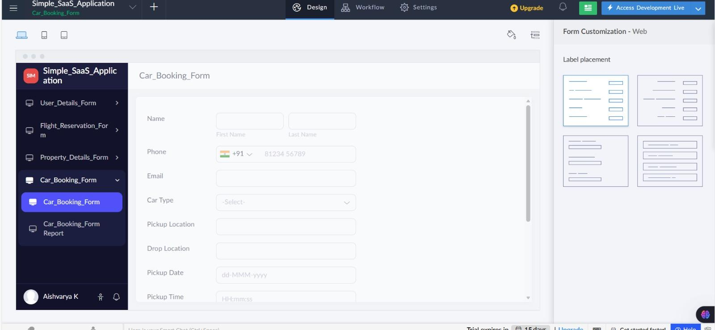

Result:

The Car Booking Reservation System was successfully developed and deployed on the cloud. Users can view available cars and make reservations online, demonstrating the SaaS model.

